

MUUGLines
The Manitoba UNIX User Group Newsletter
Volume 37 No. 3, November 2024 Editor: Trevor E Cordes
Next Meeting: November 5th, 2024 7:30pm
In Person and Online
My Favourite Browser Plugin(s)
This month we return our focus to the desktop by discussing and demonstrating a couple of Trevor Cordes’ favourite browser plugins. Yes, there are a million of these things, and everyone has their own set of “indispensables”. The choice often comes down to what itch you have to scratch, and what cool ones you’ve been introduced to by friends – or MUUG.
Trevor personally hates clutter in web pages he frequents. So he’ll show you how to clean things up with ABP and uBlock Origin. But we’re not just talking ads: nope, you can remove basically any piece of nonsense on any site with a bit of extra work. You’ll see the easy “anyone can do it” way plus the “completely insane” complex way – including when sites purposely try to sabotage your blockers. Winning!
Trevor may also discuss/demo NoScript, Dark Reader and Video Background Play Fix: all things he cannot possibly live without. If you don’t leave wanting to install a few of these then you must be from outer space!

RTFM: /bin Diving!
Our first instalment of /bin Diving was a big success, so we’re doing it again: this time with Wyatt Zacharias jumping into the bin.
If you missed it last month, /bin Diving is our segment where we pick a random program in /bin to demo and discuss and learn about as a group. It’s improv at its best!
Where to Find the Meeting
We are continuing to meet on the first Tuesday of every month. You can attend in person or online via videoconference.

If you show up in person you will be treated to more beverage choices than we’ve offered in over a decade: coffee, tea, and pop, as well as cookies. And parking is free, copious, safe, and just a handful of feet from the door.
Fortress Software Inc.
350 Keewatin St – Unit #2
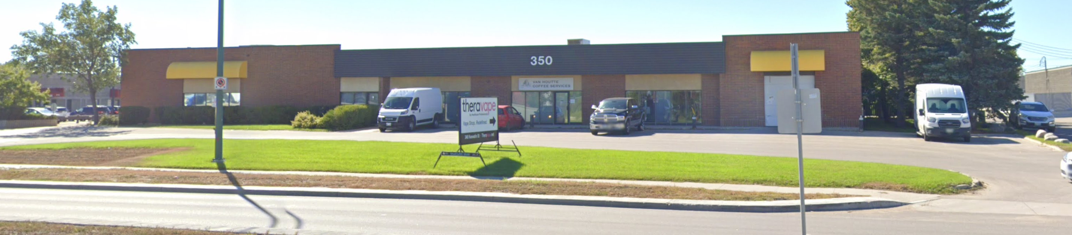
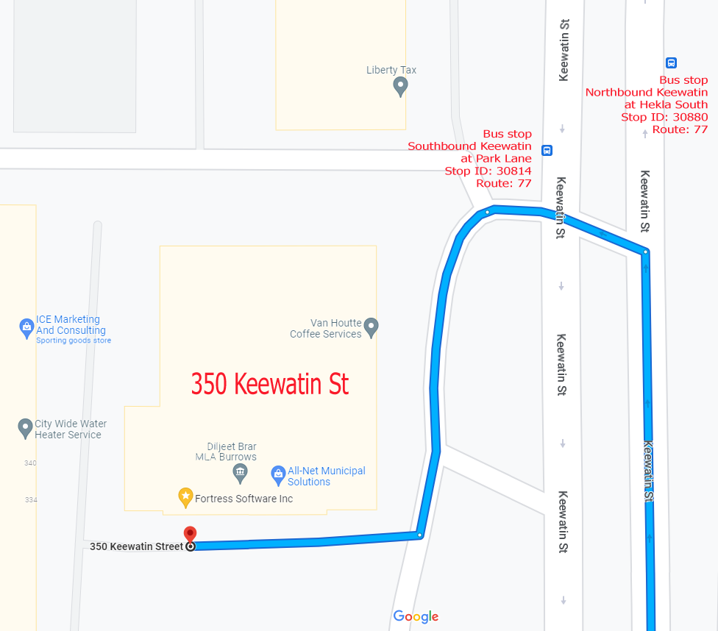
Doors will open at 7:00pm. Meeting starts at 7:30pm.
If driving, enter the lot using the most north-eastern entrance (far right in the top picture) and drive around to the south west corner of the building (see route in map detail). If you see a bunch of cars together, that’s probably the spot, as the industrial park is pretty empty in the evening. Look for the sign in the window or over the door! You can use any of the free, ample, and safe parking spots that say “reserved” or “MUUG” in front of units #1 through #4 before entering into unit #2.
Bus stops #30814 and #30880 (route 77) are only 150 meters away. The last bus leaves for Polo Park at 10:15 pm and for Garden City at 10:31 pm. Logan Ave. bus routes #19, #26, and #27 are a 600 meter (8 minute) walk to the south.
To attend via internet, check and refresh the following link after 7:00pm. There is no need to create an account in BBB, nor login. Just enter any name as your screen name and hit join.

https://muug.ca/meet

The latest meeting details are always at:

https://muug.ca/meetings/
2024-2025 MUUG Board Elections
Every November, the group holds its Annual General Meeting. The main goals of the meeting are to elect the new board, and to pass any special resolutions, if required. The Board may consist of up to ten (10) people. Those elected will serve on the MUUG board from November 2024 to November 2025. Any MUUG member in good standing may nominate any member they feel would make a good candidate, including themselves.
The MUUG Board is tasked with coordinating the meetings and other events hosted by the group. The election this year will be by acclamation as there are more positions than nominees. See MUUG By-law 5.(c) and 10.(d).
The following members are currently on the board and are entering their names for re-election (alphabetically by last name):


Alberto Abrao
Alberto Abrao (BBA) started his journey with FOSS in 1997, when he first installed Slackware on his computer. He quickly seized the power bestowed upon him, and embarked on a quest to extract the most out of any tech that ended up in his possession, and helping others get the most out of their tech as well. He also likes to fix things around the house and is always on the lookout for a mint 2000-2004 Ford Focus with a manual transmission to wrench on. He is a newcomer who found in Winnipeg a place to call home, and in MUUG a place to exchange knowledge and experiences.

Trevor Cordes
Owner, Tecnopolis Enterprises
Trevor Cordes (B.Sc. CompSci) has owned and operated Tecnopolis Enterprises – a computer VAR, programming and consultancy company – since 1999. Linux and FOSS have been the keystone of Tecnopolis since inception. Since becoming a family man, he has shifted his primary focus to e-commerce development and operation. Trevor was President of the Atari ST User’s Group for four years in the ‘90s. He prefers Fedora, Perl and PHP.

Gilbert Detillieux
Information Technologist, University of Manitoba
Gilbert Detillieux has been working with UNIX as a programmer, system administrator, and trainer since 1980. He worked as a computer consultant specializing in UNIX, from 1983 to 1989, and is currently working as an Information Technologist for the University of Manitoba’s Department of Computer Science, where’s he’s worked since 1989, installing, supporting and upgrading the department’s network and UNIX server infrastructure. He was co-founder and past president of the Technical UNIX User Group (now MUUG), and has been an active member of the MUUG board ever since.

Kevin McGregor
Systems Administrator, City of Winnipeg
Kevin McGregor provides server, platform and infrastructure support in the City of Winnipeg’s Information Systems Department. After having briefly used UTS on an Amdahl mainframe in university in the mid-80s, he dabbled in Coherent and then converted to Linux and OpenBSD. He has been a member of MUUG since the early 90s, edited the group’s newsletter for a number of years, presented various topics at MUUG meetings and has served on the board for the majority of his membership.

Tyhr Trubiak
Developer
Tyhr Trubiak has been a member of MUUG since 2013. He manages Linux and Windows servers. His first exposure to UNIX was when he received his B.Sc. CompSci at the University of Manitoba, which he found similar to his first love - the Commodore Amiga. He was an ASP web developer back in the early days. He has enjoyed 2D node-based digital compositing with Blackmagic Fusion, acting, fitness, downhill skiing and anything Jeep related.

Brad Vokey
Owner, Fortress Software
Brad is the owner of Fortress Software Inc. and the creator of the Matchmaker Fundraiser (aka “Matchomatics” - a fundraiser that provides compatibility lists for millions of students across Canada and the US). Brad started the company in 1985 using
Apple ][ computers and 6502 machine language. Then switched to 68000 machine language on Atari ST computers in 1986 and then to C on Atari TT030 computers soon after. The original C program and Atari TT030 computers are still very much alive and in use to this day! In 2004, Brad started using Linux on Tecnopolis servers, and joined MUUG in 2006. He previously served on the board of the Atari ST Users Group (STUG) and became a board member of MUUG in 2011. He has been keeping our finances in order as your MUUG treasurer since 2013.

Wyatt Zacharias
Lead Cloud Developer, Wawanesa Insurance
Wyatt Zacharias has been a member of MUUG since 2011, and president of MUUG since 2014. During the day, he works as Lead Cloud Developer at Wawanesa Insurance, where he manages an assortment of virtual Linux servers in AWS, and various serverless cloud solutions. In previous roles, he has worked with RedHat, SuSE, and HP-UX. Wyatt prefers to run Fedora, as well as Raspbian on the many Raspberry Pi’s he owns. He is a licensed amateur radio operator and enjoys experimenting with open source software for radio communication. Wyatt graduated from Red River College in 2014, and has certifications from AWS and RedHat.
The following member has been nominated to join the board for the first time.

Kevin Abedi
Kevin started working with computers at a young age and by shunning people aside, become the tech wiz of the family. A traitorous Windows user, he has infiltrated MUUG in order to learn more about the secrets of UNIX. Interests includes automation, IoT and quality of life tooling.
Thank you to Chris Audet, who will not be returning as a board member this year.
Thank you for supporting the user group! Let’s keep working hard to help our workplaces and communities with friendly, and useful technologies.
Perl Drops Support For Some OSes
Many members will be heartbroken to hear that the Perl language has dropped support for some terribly relevant and important platforms:
Perl v5.38: Ultrix (final release 1995)
Perl v5.36:
AT&T UWIN (final release 2012, a UNIX compatibility layer for Windows)
DOS/DJPP (a port of GNU toolchain to 32-bit x86 running DOS)
Netware (final release 2009)
But don’t fret! You can still run the latest Perl on your Amiga, Hurd and VMS! (Try: man perlamiga)
Hey wait, where’s Atari ST? Blasphemy! Argh, upstaged by Amiga again.
Door Prizes
We have a dead tree book to give away this month: High Performance Images by Bendell et al on O’Reilly Media. It’s from 2016 but still contains 99% of the relevant details you need to know about computer and web images, including WEBP. (New formats are very slow to appear and gain acceptance, and most technology improvements, such as vastly better compression, were achieved long ago.)

The JPEG section alone is worth the price of admission, as the ideas used in JPEG apply to most newer formats. You’ll learn how subsampling works to “reduce the the size of the color component bitmap by half” or three-quarters.
Discover how the Discrete-Cosine Transform (DCT) converts “images from the spatial domain to the frequency domain”, and quantization provides the lossy, but massive, file size savings. These ideas draw from wave, frequency and AC/DC electrical theories as they turn images from a bitmap into more of a textural frequency map. Just the stuff every nerd would love to learn! And all in the typical well-written, easy to understand O’Reilly way.
There are also a couple of newer batches of e-books you may want to peruse as a possible door prize choice this month.
*NIX-themed stickers continue to be offered as a couple of prize draws, as well as Communications of the ACM magazines graciously donated by Dan Keizer.
And, as usual, one lucky winner can select an e-book graciously donated by Michael W. Lucas of Tilted Windmill Press (see advertisment on last page).
Everyone is encouraged to enter the door prize draw: both in-person and virtual attendees. You don’t have to be a member to enter, but members have exclusive access to the first draw. Members also get the privilege of not having to be present (physically or virtually) for the draw in order to claim their non-physical prize. However, physical prizes can only be selected by in-person attendees. If you attend online you’ll have to select from one of the e-books if you win a door prize.
Unicode 16 Released
September 10, 2024 marks the release of new major version 16.0.0 of Unicode. You get 5185 new characters, to bring the total set up to 154,998.
New scripts include Garay (modern West Africa); Gurung Khema, Kirat Rai, Ol Onal, Sunuwar (modern NE India and Nepal); Todhri (historic Albanian); and Tulu-Tigalari (historic SW India).
But wait, there’s more! – Seven new emojis plus 3995 additional Egyptian Hieroglyphs, and 700 “symbols from legacy computing environments”. (Now that sounds cool...)
This will thrill all programmers and vendors who just recently got around to supporting Unicode 15! For example, Perl only added 15 support in 5.38, about a year ago. Get back to the drawing glyphing board everyone!

https://www.unicode.org/versions/Unicode16.0.0/
MUUG Server Updated
The MUUG distro mirror, mailing list and videoconferencing server – muug.ca – was upgraded to a newer OS in mid September. It was running Debian 10, which had fallen into EOL. It is now running Debian 12. The upgrade was done via remote ssh access and all steps went fairly smoothly, except for some sweat and new grey hairs while the new-as-of-2020 server checked its RAM on reboot for more minutes than expected.
The upgrade path went through Debian 11, as recommended, which was running on the server only for a brief couple of hours. Debian’s upgrade path runs in-place while in-OS just like a regular update, in contrast to Fedora which reboots into a special offline upgrade mode.
Total server downtime from a mirror-serving standpoint was only 7 hours, almost all of which was in the pre-dawn hours for minimal user impact.
Mailing list downtime was about 2 days. Debian 12 provides Mailman 3 (MM3) instead of the aging Mailman 2. It’s not really an upgrade as much as it is a completely new program (actually 3 programs!) that just happens to have the same name. The upgrade is known to be a nightmare made in the depths of Hades.
MUUG is now one of the few places where MM3 is running on nginx instead of Apache, and sendmail instead of postfix. Yes Virginia – it is possible!
All of the existing archives should still be intact and reachable. MM3 has a great new full-text search feature, so check it out. See what funky stuff you wrote 12 years ago!
All members are encouraged to subscribe to at minimum Muug-announce; and Roundtable is recommended as well.

https://muug.ca/maillists.php
The mirror continues to run on ZFS, which has proven very reliable – as long as you don’t let it get to 99% full...

A big thanks to Les.net for providing MUUG with free hosting and all that bandwidth! Les.net (1996) Inc. is a local provider of VoIP, Internet and Data Centre services. Contact sales@les.net by email, or +1 (204) 944-0009 by phone.
Except where otherwise noted, all textual content is licensed under a Creative Commons Attribution-ShareAlike 4.0 International License.

https://creativecommons.org/licenses/by-sa/4.0/
MUUG would like to thank Michael W. Lucas for donating one of his ebooks every month as a door prize. You can view and purchase his tech books here:

https://www.tiltedwindmillpress.com/product-category/tech/
Help us promote this month’s meeting, by putting this poster up on your workplace bulletin board or other suitable public message board:

https://muug.ca/meetings/MUUGmeeting.pdf

